PLACEMENT LEARNING AGREEMENT PRE-READING
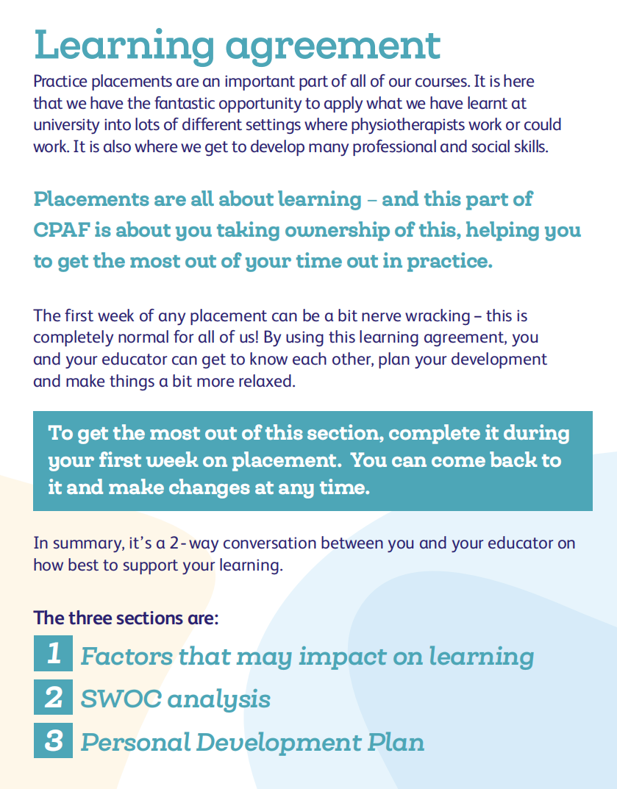

Factors that May Impact on Learning (Optional)

This section provides a space for learners to share any information that could affect their learning experience on placement. Sharing such details encourages open communication between the learner and practice educator(s), enabling appropriate support measures to be implemented where necessary. Identifying these factors early on helps to create a more inclusive, supportive learning environment that accommodates the learner’s unique needs, ensuring they can fully engage in the placement experience.

Possible factors and examples include:

- Risk of discrimination: Concerns related to protected characteristics such as age, disability, or gender reassignment (e.g., a student worried about discrimination based on sexual orientation).
- Accessibility adjustments: Needs related to physical access or mobility aids (e.g., requiring a wheelchair-accessible environment or assistive technology).
- Social or family circumstances: Personal or family obligations that could impact attendance or performance (e.g., being a caregiver or long travel times).
- Health or well-being issues: Ongoing physical or mental health conditions (e.g., chronic illness, anxiety, or depression) that may affect placement engagement.
- Financial issues: Constraints due to travel expenses or other costs associated with the placement (e.g., difficulty affording daily commute costs).
- Religious or cultural beliefs: Specific practices that may influence scheduling or participation (e.g., fasting during Ramadan or specific dress code requirements).
- Previous placement challenges: Learning difficulties or interpersonal issues encountered in past placements (e.g., a previous conflict with a supervisor affecting confidence).
- Previous experiences (bereavement, personal, or family health issues): Any personal experiences, such as a recent family illness or death, that might impact focus or emotional well-being during the placement.

SWOC ANALYSIS
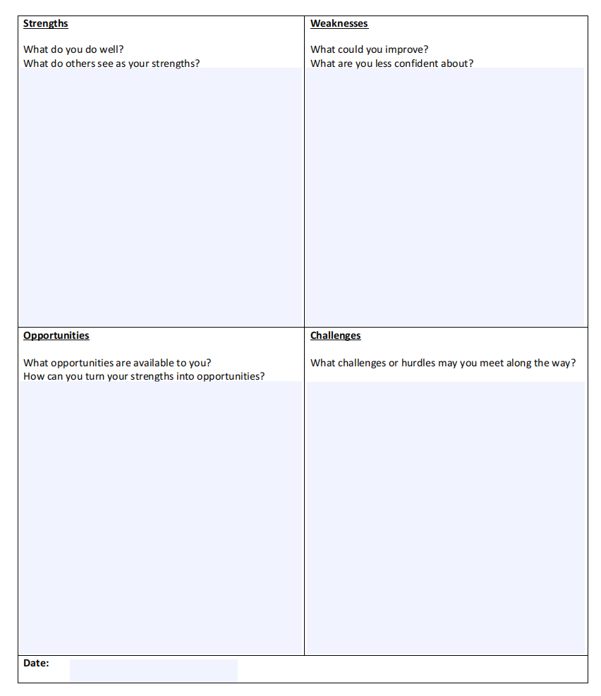
PERSONAL DEVELOPMENT PLAN
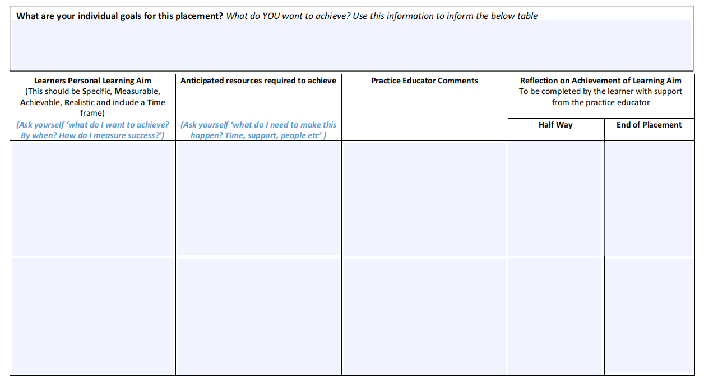
Classwork:
- Go into your module.
- Download a copy of the CPAF specific to your level.
- Complete the SWOC analysis for and learning agreement for your group.
- Put the name of your group on the your CPAF.
- Complete the halfway assessment for on the CPAF for your group
- Submit your group CPAF.

